VIRTUAL LEARNING ENVIRONMENT

REQUIREMENTS GATHERING
AND
PROBLEM DESCRIPTION
FOR
VIRTUAL LEARNING
ENVIRONMENT

The Great Mind Challenge - Project Scenario Template

 | Name of the Project |  | Virtual Classroom System
 | Objective/ Vision |  | Developing a virtual classroom system to promote a greater count of students to splurge into the field of Education. It integrates the benefits of a physical classroom with the convenience of a ‘no-physical-bar’ virtual learning environment, minus the commuting hazards and expenses. It will usher in the immense flexibility and sophistication in the existing learning platform structures, with the perfect blend of synchronous and asynchronous interaction. It provides a means of collaborative learning for the students.
 | Users of the System |  | A. Students  B. Faculty  C. College Management (Dean, HODs, Principal)  D. Administrator
 | Functional Requirements |  | - Students can choose courses, attend lectures, take exams, view their attendance records, progress reports etc as per their convenience.  - Registration for multiple courses.  - Attend lectures either at the scheduled time or on request view lecture at a later time.  - Faculties can take lectures, upload assignments, announcements, evaluate answer sheets and also can upload lectures and other discussions in various formats as in videos, power point presentation etc.  - Upload and Download of various assignments, college notices, student's notices, journals, videos.  - Real Time collaboration among – A/B via chat rooms, shared and interactive whiteboards.  - Asynchronous communication in the form of Emails, discussion boards that enable communication to occur at "convenient-times" that suit student schedules and are not accessed at simultaneous or prearranged times.  - There can be forums, blogs etc to discuss various queries and to put up suggestions posted both by students and teachers.  - Administrator can generate reports, log files, backup/recovery of data at any time.  - Shared documents and media library that can help in active learning of a student.  - Images library  - One-to-Many (B->A), Many-to-One(A->B) and Many-to-Many (B->B) information sharing.  - Availability of voice mail box to allow faculties to get the descriptive messages left by the students.  - Per day attendance submission system  - Provision of resources to arouse the interest of students in extracurricular activities like public speaking etc and to grasp the chance to enhance their personalities.  - Users must have valid User ID and password to login thus creating their individual profiles.  - Students can take up various quizzes which can help them to realize their inbuilt talents in various fields.
 | Non-functional requirements (At least Four) |  | - Secure access of confidential data (user’s details). SSL can be used.  - 24 X 7 availability  - Better component design to get better performance at peak time  - Flexible service based architecture will be highly desirable for future extension
 | Optional features |  | - Send SMS/Email to any user in case of any class Re-Schedule, Result declaration, Notice Upload etc.  - Drag and Drop functionality.  - Customizable color schemes and skins.
 | User interface priorities |  | A. Professional look and feel  B. Use of AJAX at least with all registration forms  C. Browser testing and support for IE, NN, Mozzila, and Firefox.  D. Use of Graphical tool like JASPER to show strategic data to admin  E. Reports exportable in .XLS, .PDF or any other desirable format
 | Reports |  | A. Time based and on request Attendance records.  B. Students Progress Report on request .  C. Faculty performance reports.
 | Other important issues |  | A. Website must be highly customizable and user friendly.  B. Security should be kept a high priority issue.
 | Team Size | 5 members
 | Technologies to be used | UML, J2EE, XML, AJAX, Web 2.0, Web-services, SOA
 | Tools to be Used | RAD/ROSE/RSA/Eclipse/WSAD/ WebSphere Portal  WAS/WAS CE  DB2 Express – ‘C’ or DB2 UDB  Linux will be the preferred OS.
 | Final Deliverable must include | A. Online or offline help to above said users, Application deployment executive and developer  B. Application archive ( .war/.ear ) with source code  C. Database backup and DDL Script  D. Complete Source code

Software Requirement Specification For Virtual Learning Environment (VLE)

INTRODUCTION
FOR
VIRTUAL LEARNING ENVIRONMENT

- Introduction
  - Purpose
  - Scope
  - Definitions, acronyms and abbrevations
  - References
  - Document overview

Introduction:
A virtual learning environment (VLE) is a Web-based platform for the digital aspects of courses of study, usually within educational institutions.
  - Purpose
VLE is a safe and secure environment that is reliable, available online and accessible to a wide user base. A user should be able to move between learning platforms throughout their life with no loss of access to their personal data. The concept of a learning platform accommodates a continuously evolving description of functionality changing to meet the needs of the user.
  - Scope
We describe what features are in the scope of the software and what are not in
the scope of the software to be developed.
In Scope:
1. Information regarding the course syllabus, course duration and so on.
2. Giving alerts regarding the submission of assignments.
3. Their performance should be mailed after every exam.
4.Giving alerts to the user regarding if any new video is uploaded regarding his course.
5. user authentication.
Out Scope:
- Never describes about their last login.
- Never describes about the amount of time used.
- Videos cannot be downloaded.
  - Definitions, Acronyms And Abbreviations:
Definitions
a. Virtual: virtual meansnot physically existing as such but made by software to appear to do so
b.Security: A set of all transactions pertaining to a company share or a bank account.
c. Users: Student,faculty,Management,Admin.
d. Admin: Application administrator responsible for application management.
e. Management: Registered users which manage the entire working of Virtual Classroom.
f. Faculty: Registered teachers of VCS to teach the students studying in VCS.
g. Students: Registered users of VCS as the students of the classroom.
h. Lecture: A Video/PowerPoint Presentation/Notes on any subject/topic related to any course.
i. Discussion Time: A scheduled time slot during which a faculty will be available (online) for discussion with students and their doubt clearance.
j. Assignment: Two types of assignments :
Self-Practice --> The one's those are not to be submitted and will just work as practice exercises.
Submission Assignments -->These are to be submitted within a given a deadline.
k. Examination: Test conducted to evaluate the performance of a student in a particular subject/course.
l. Attendance: Statistical report of a student showing the number of classes attended by him/her in comparison to total classes being held.
m. Progress Report: Report showing the progress of a student after the examination is being conducted.It will be a cumulative course report.
Acronyms and abbreviations
VLE :Virtual Learning Environment
HTML: Hypertext Markup Language.
EJB: Enterprise Java Beans.
J2EE: Java 2 Enterprise Edition
HTTP: Hypertext Transfer Protocol
HTTPS: Secure Hypertext Transfer Protocol
PHP: Hypertext Pre-processor
  - References:
- www.wikipedia.com
- www.nptel.ac.in
- www.edx.org
Books referred:
- UgrasenSuman
- Pressman
1.5 Overview of the document
The rest of this SRS is organized as follows: Section 2 gives an overall description of the software. It gives what level of proficiency is expected of the user, some general constraints while making the software and some assumptions anddependencies that are assumed. Section 3 gives specific requirements which thesoftware is expected to deliver. Functional requirements are given by various usecases. Some performance requirements and design constraints are also given.Section 4 gives some possible future extensions of the system. Finally theappendices in Section 5 describes the list of references.

GENERAL DESCRIPTION
FOR
VIRTUAL LEARNING ENVIRONMENT

- General description
  - Product Perspective
  - Product Functions
  - User Characteristics
  - General Constraints
  - Assumptions and Dependencies

2.1 Product Perspective
Virtual learning environment should enable the users to develop a rich multimedia presentation combining presentation slide, video and images. This software can be used for developing courses that can later be released on the Internet or delivered in some other electronic medium.
2.2 Product Functions
VLE should support the following use cases:
Class of use cases | Use cases | Description of use cases
Use case related to Domain Name. | Domain name | User initiates domain name of the website.
Use cases related to  system authorization.
  Login
  Change Password
  Login into VLE.
  Change VLE password.
Use case related to Update Profile. | View Profile | User can View and update self profile.
Use case related to Search Course. | Search Course | User searches for a course.
Use case related to Course Registeration. | Course Registeration | User register for a course.
Use case related to Syllabus. | View Syllabus | User Can view the syllabus pertaining to the registered course.
Use case related to Discussion. | View Discussion time | User can view the discussion time scheduled by various faculties.
Use case related to Notices. | View Notices | User can view the files consisting assignments etc.
Use case related to Taking Test. | Appear for test | User can appear for test for registered subject.
Use case related to Generating Report. | View Report | User can view his report for taken test.
Table 1:Use cases for Virtual learning Environment
2.3 User Characteristics
1.The user should be familiar with the particular course he/she want to undertake.
2. The user must require basic internet skills.
2.4 Principal Actors
The principal actors are User, Parents, Faculty.
2.5 General Constraints
1.To access VLE the system requires internet connection.
2.6 Assumptions and dependencies
a. Full working of VLE is dependent on the availability of Internet connection.

SPECIFIC REQUIREMENTS FOR
VIRTUAL LEARNING ENVIRONMENT
- Specific Requirements
  - Functional requirements
    - Functional requirement 1
      - Introduction
      - Input
      - Processing
      - Output
    - Functional requirement 8
  - External interface requirements
  - Performance requirements
  - Design constraints
  - Security requirements
  - Maintainability requirements
  - Reliability requirements
  - Availability requirements
  - Database requirements
  - Documentation requirements
  - Operational requirements
  - Site adaption constraints

3. Specific Requirements
3.1 Functional Requirements:
3.1.1 Functional requirement 1:
Course Registration
3.1.1.1 Introduction:
User has to register for a particular course inorder to view the course syllabus, course details, appear for test and to view the results.
3.1.1.2 Input:
The user has to fill all the details of the user in the registration form. The necessary fields are contact number, Aadhaar no, phone number, E-mail id and so on.
3.1.1.3 Processing:
Validations checks are performed on the input data by the user/administrator like:
- Mandatory fields should not be kept empty.
- All the entries in database should be as per syntax.
After entering the details the user clicks on submit button, then the information is stored in database.
3.1.1.4 Output:
A dialog box containing “Registration Sucessful” will be displayed, otherwise displays an error message.

3.1.2 Functional requirement 2:
Login

3.1.2.1 Introduction:
The login page is required for the user to access the details about the courses available.
3.1.2.2 Input:
User name along with password should be given.
3.1.2.3 Processing:
User has to provide unique userid and password to get into the homepage to access his account. These names are checked in the database. If the given username and password are matched the they can view the homepage otherwise they need to enter the details again.
3.1.2.4 Output:
The user is redirected into his account, otherwise an alert message will be given to the user “please enter valid username or password”.

3.1.3 Functional requirement 3:
Change password
3.1.3.1 Introduction:
This is required for the users who forget their password then the user can change the password with the help of this page.
3.1.3.2 Input:
User should enter his username and the last password he remembers.
3.1.3.3 Processing:
User initiates the password change command. User is prompted for the old password, new password and confirm new password. After filling all the fields he clicks on the submit button, then the user password will be stored in the database. User gets a message to his E-mail that password was changed.
3.1.3.4 Output:
If the new password and confirm password are matched then new password will be updated, otherwise an error message containing “password mismatch” will be displayed on the screen.
3.1.4 Functional requirement 4:
Search Course
3.1.4.1 Introduction:
This is used to display the details of the particular course asked/requested by the user.
3.1.4.2 Input:
After the user login, then the user should searches for a particular course in the search box.
3.1.4.3 Processing:
User clicks on the search box. System asks for the user to enter a course name. User enters by the course name and lick on search icon. If the given course exists in the database then the details of the course will be displayed.
3.1.4.4 Output:
The output will be the content regarding the course entered by the user. If the course name does not exist then it displays “course does not exists”.

3.1.5 Functional requirement 5:
View Profile
3.1.5.1 Introduction:
If the user wants to view/edit his profile then there is an edit button, on clicking the edit button user can edit his profile.

3.1.5.2 Input:
First the user must be logged in using the username.
3.1.5.3 Processing:
The user on clicking on the edit button, then the user can be able to edit all his details like e-mail id, contact number and so on.
3.1.5.4 Output:
After making all the required changes then the user clicks on “save changes” button, then the corresponding changes will be made to the database.
3.1.2 Functional requirement 2:
View notices
3.1.6.1 Introduction:
View notices module is used to view day to day news and events. It displays the list of events scheduled according to the date.
3.1.6.2 Input:
The user must be logged in with corresponding username and password.
User initiates My diary icon.
3.1.6.3 Processing:
When user initiates My diary icon the corresponding list of events from the database are displayed on the screen according to the date modified. It displays curriculum events and list of my events.
3.1.6.4 Output:
My dairy displays list of curriculum events according to the date i.e., list of assignments scheduled for the user and list of my events i.e., list of assignments submitted by the user.

3.1.7 Functional requirement 7:
View Report
3.1.7.1 Introduction:
When user clicks on the Assignment Grades, it displays the grades assigned to the assignment submitted by the user.
3.1.7.2 Input:
User must be logged in and should submit at least one of the assignment to the date given.
3.1.7.3 Processing:
As the user initiates Grades icon, it displays the list of grades assigned to the assignments submitted by the user. It displays only the grades but not percentage or rank.
3.1.7.4 Output:
The output will be the grades, if the user does not submit any assignment by default “only grades are visible” will be displayed.
3.1.8 Functional requirement 8:
Add a course
3.1.8.1 Introduction:
This icon is for the administration to add a course to make it accessible for the users.
3.1.8.2 Input:
It takes course name and course title as input and there is a check box enable viewing.

3.1.8.3 Processing:
After all the input values are given administrator creates the course by clicking on create button. Here the course name and course title are mandatory columns. These courses can also be modified by the tutors.
      - Output:
The output will be the course is created with the given name and title and if the course name already exists then it displays a message “course already exists”.

3.2 External Interface Requirements

Screen1:
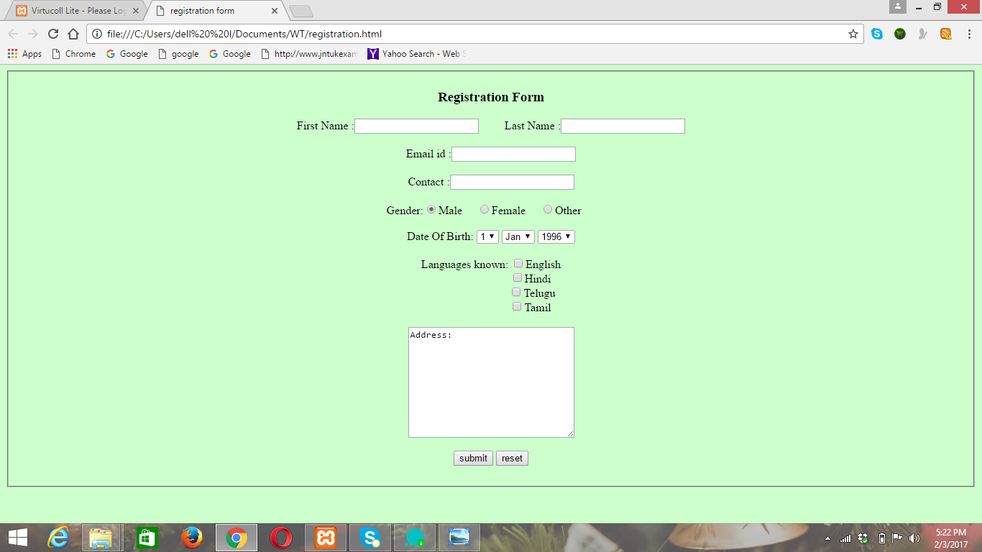
The above screen describes the registration of a user for a particular course he/she wants to learn. This registration forms the input fields like his/her name, E-mail id, contact number, and an address field as soon as the user clicks on the submit button the given input is taken to the database and stored in the database with user id as the primary key which is set as auto-increment.

Screen 2:
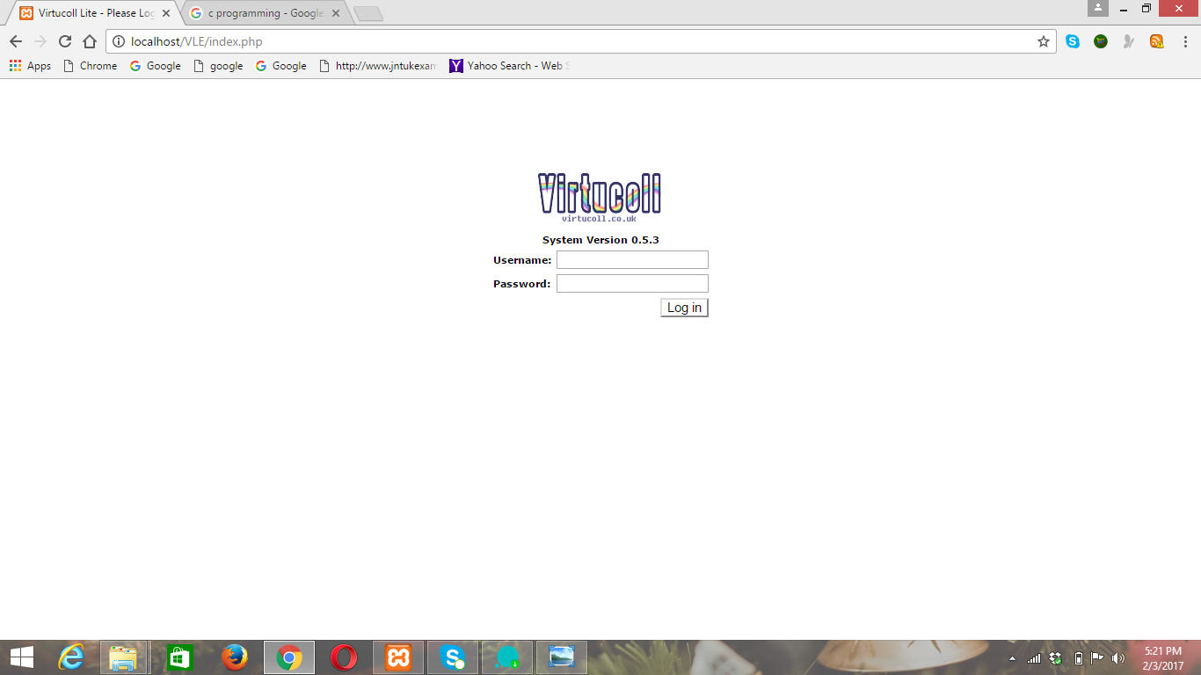
The above screen describes the login page which takes the username and password as input and there is a login button. The user after entering the username and password and clicks on the login button. The user is allowed for next page only if the username and password are correct i.e., they should be matched with data available in the database. Ifthe username and password are correct then the user is displayed with the homepage.
Screen 3:
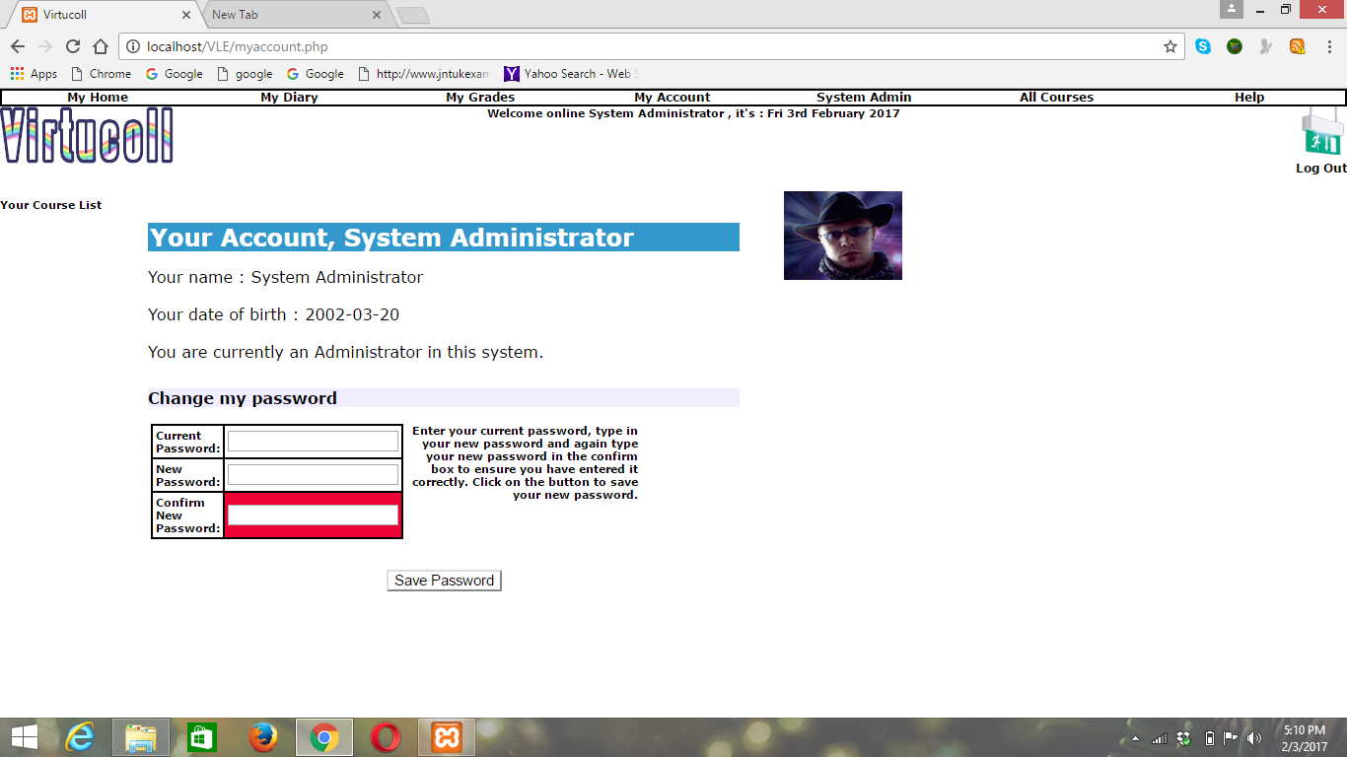

The above screen allows the user to change the password, if the user has forgotten his password or if he feels that it is unsecured. There are three textboxes named as current password, new password and confirm password. The user is initially prompted to give the current password and then new password and he is again asked to confirm new password, if the new password and confirm password are same and if user initiates save password button the password must be updated into the database, otherwise user should be displayed with the message re-enter the password.
Screen 4:
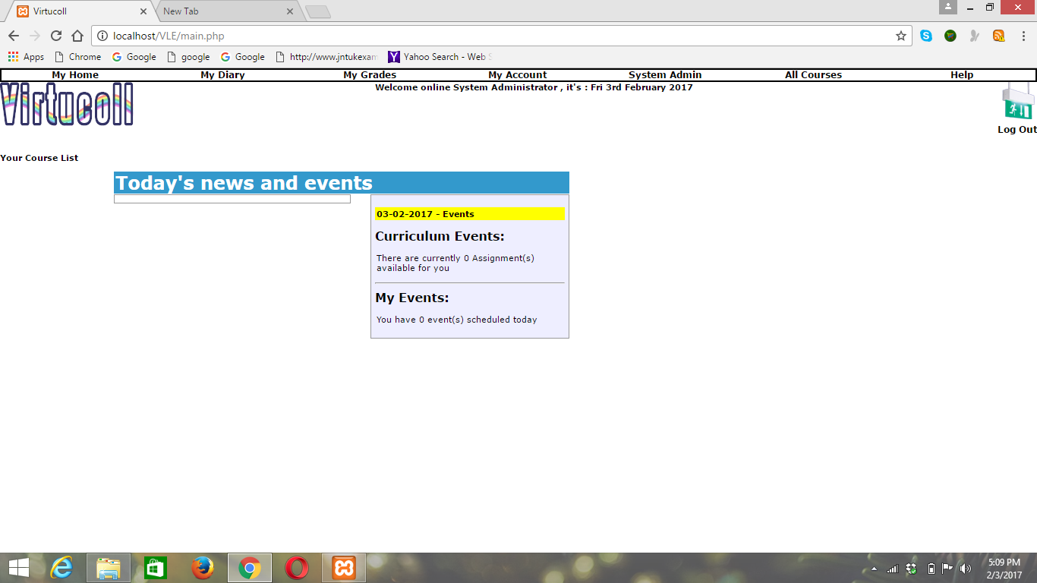
The above screen displays the list of notices like news and events regarding the assignments submission due dates of the particular user logged in. This screen displays two types of events curriculum events and my events. Curriculum events contain the list of assignments available where as my events contains the list of due dates for assignments or any new video uploaded, to be watched by the user.

Screen 5:
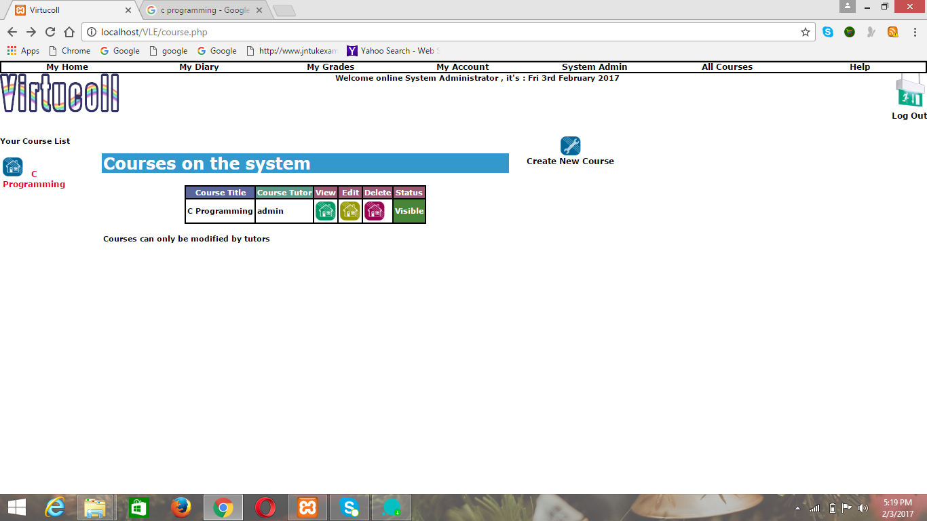
The above screen is displayed only when the user searches for a particular course. This module displays the list of course details. Only the administrator has the right to modify the course details i.e., add a course, delete a course and so on. The user types the course name required on the search box and clicks on the search symbol then the user will be displayed with the course requested if it is existed otherwise the user will be displayed with the message “sorry. Course did not found..!”.
Screen 6:

The above screen displays the grades to the list of assignments submitted. As the user initiates my grades icon, the user will be displayed with assignments name, course, assignment grade, feedback. This module will display only the grades to the assignments submitted, but not the percentages or overall rank.
Screen 7:
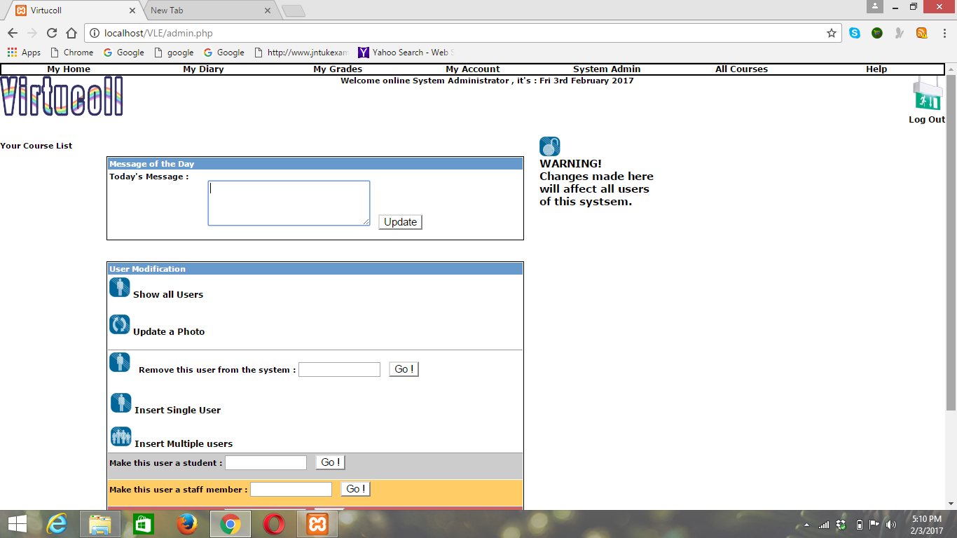
The above screen indicates view/edit profile. In this screen user can update the photo. The admin has also some permissions that can remove the particular user from the system, he can also make the particular user as a student and particular user as a staff member if he/she is interested with the prior permission of the user. The user can also give the message i.e., what he learnt in the today’s session can also be updated and saved in his profile.

Screen 8:

The above screen is for the administrator who can add a particular course for the users. The admin initiates add a course button and then he is displayed with some of the details like course name, course title, enable viewing and create button. After filling all the mandatory fields on clicking create button a particular course is created. The ciurse can only be modified by the administrator. The user does not have any permission to access or modify the administrator information.
3.3 Performance Requirements
1. The system should be easy to handle.
2. System should give expected performance results.
3. The response time should be small.
3.4 Design Constraints
1. security: The files in which the information regarding securities should be secured against malicious deformations.
2. Fault Tolerance: Data should not become corrupted in case of system crash or power failure.
3.5 Security Requirements
1. We are going to develop a secured database.
2. Depending upon the category of user the access rights are decided.
3.6 Maintainability Requirements
1. The system must be flexible of all the features.
2.Maintainanceof reports up to date.
3. Database backup and DDL scripts.
3.7 Reliability Requirements
1. The system should recover in 5min when it is down.
2. The system should generate the error messages and when user attempts to enter invalid data.
3. The system will show appropriate messages at terminal when it is down.
3.8 Availability Requirements
1. 24*7 availability.
2. Secure access of confidential data.
3. System must be able to extend to store new content of information.
4. Users can also interact through their mails.
3.9 Database Requirements
All the data will be saved in the database. The data allows concurrent access and will be kept consistent at all times, requiring a good database design.
3.10 Documentation Requirements
An installation document will be provided that includes the installation instructions and configuration guidelines, which is more important to a full solution offering. Most users also appreciate documentation defining any known bugs and works around.
3.11Safety Requirements
The database may get crashed at any certain time due to virus or operating system failure. Therefore, it is required to take the database backup, because database is not costly. Proper UPS/inverter facility should be there in case of power failure.

3.12 Operational Requirements
The system is limited by its operating server in terms of maximum number of users it can support at a given time.
3.13 Site adaption constraints
The component will be adapted to the overaching system at the conclusion of the system creation.

OBJECT-ORIENTED ANALYSIS FOR
VIRTUAL LEARNING ENVIRONMENT

Fig:1Use case diagram
Usecase specifications:
Use case related to domain name:
Use Case 1: domain name
Primary Actor: User
Pre-Condition: Internet connection available.
Main Scenario:
- User initiates domain name of the website.
- Initially home page of the website should be displayed. User is also asked for the initial login and password.

- User specifies the home directory and login/password.
- If the user is new registration is available at the home page. System creates the working files in the specified home directory. Working files contain:

  - Authorization information.

Alternate Scenario:
5(a). Network failure.
5(a)1. If the domain name is wrong another webpage is displayed.

Use cases related to system authorization:
Use Case 2: Login
Primary Actor: User
Pre-Condition: User must be registered first.
Main Scenario:
- Start the application. User prompted for login and password.

- User gives the login and password.
- System does authentication.
- Main screen is displayed.
Alternate Scenario:
4(a). Authorization fails
4(a)1. Prompt the user that he typed the wrong.
4(a)2. Allow him to re-enter the password.
Use Case 3: Change Password
Primary Actor: User
Pre-Condition: User logged in
Main Scenario:
1. User initiates the password change command.
2. User is prompted for old password, new password and confirm new password.
3. User gives the old password, new password and confirm new password.

4. System does authentication.
5. New password is registered with the system.
Alternate Scenario:
4(a). Authorization fails

4(a)1. Prompt the user that he typed the wrong password
4(a)2. Allow him to re- enter the password.
4(b). New password and confirm new password do not match.
4(b)1. Allow him to re-enter the attributes.
Use Case 4:View/Update Profile
Primary Actor: User
Pre-Condition: User should register to the page.
Main Scenario:
- User can View and update self profile ( Password, Name, Date of Birth, Address, Email Ids, Contact Numbers etc.).
Alternate Scenario:
- User cannot view if he/she is not registered.

Use Case 5:Search Course
Primary Actor: User
Pre-Condition: User logged in
Main Scenario:
- User searches for a course.
- User gets basic knowledge about the selected course.
Alternate Scenario:
- Webpage cannot be displayed if the selected course is not present.
Use Case 6:Course Registration
Primary Actor: User
Pre-Condition: User should register to the page.
Main Scenario:
- User selects course to be registered.
- User can get full knowledge about the selected course.
- Details about the course should be sent with an E-mail to a respective person.
Alternate Scenario:
- Course registration is not possible if user did not register to the page.
Use Case 7:View Syllabus
Primary Actor: User
Pre-Condition: User should register to the page.
Main Scenario:
- User Can view the syllabus pertaining to the registered course.
Alternate Scenario:
- User cannot view if he/she is not registered.

Use Case 8:View Discussion time
Primary Actor: User
Pre-Condition: User should register to the page.
Main Scenario:
- User can view the discussion time scheduled by various faculties .
- User can view their test schedules.
Alternate Scenario:
- User cannot view if he/she is not registered.
Use Case 9:View notices
Primary Actor: User
Pre-Condition: User should register to the page.
Main Scenario:
1.User can view the files consisting assignments etc.
- User can read notices uploaded by higher authorities.
Alternate Scenario:
- User cannot view if he/she is not registered.
Use Case 10:Appear for test
Primary Actor: User
Pre-Condition: User should register to the subject.
Main Scenario:
- Userwho completes his part of the syllabus of a particular subject/course and have done a particular set of assignments related to that subject/course can appear for the test.
Alternate Scenario:
- User cannot view if he/she is not registered.
Use Case 11:View Report
Primary Actor: User
Pre-Condition: User should take a test.
Main Scenario:
- Usercan View his/her progress report.

Alternate Scenario:
- User cannot view his/her report if he/she did not appear for the test.

DATA-ORIENTED ANALYSIS FOR VIRTUAL LEARNING ENVIRONMENT

Data Description Table:
Data Item | Description
Admin  Authority  Course code  Course number  Document  Email  Material id  Material name  Password  Registration  Subject code  User id  User name  Videos | The person who controls and maintains the database.  The permission given to a particular user and admin.  The code name given to a particular course.  The code number given to a particular course.  The material shared by the tutor to the learners.  The material given by the particular user.  The id given to the material.  The name given to the material.  The password given by the user to his profile.  The specified values should be filled in the form for successful registration.  The code number of particular subject.  The id number of the particular user.  The name given by the user to his/her profile.  The videos uploaded by the user.

Table 2: Data description table for VLE

Relation between Entity and attributes

Entity | Relationship
Admin  Learner  Study material  Tutor | Username, password, authority, user-id, Email.  Username, password, course code, course name, email, user_id, authority.  Material id, material name, user id, video, test papers,  Authority, email, subject code, user id, user name, password.

Table 3: Entity and attributes relationship for VLE

Fig 2: E-R diagram for virtual learning Environment

STRUCTURED ANALYSIS
FOR
VIRTUAL LEARNING ENVIRONMENT

Fig 3:Dataflow diagram for Course Registration
Fig 4: Dataflow diagram to view profile

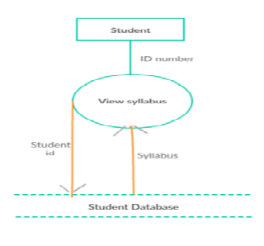
Fig 5:Dataflow diagram to view syllabus

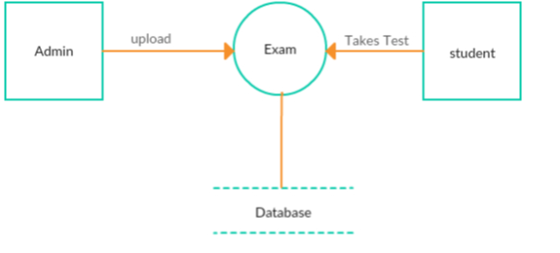
Fig 6:Dataflow diagram to take test

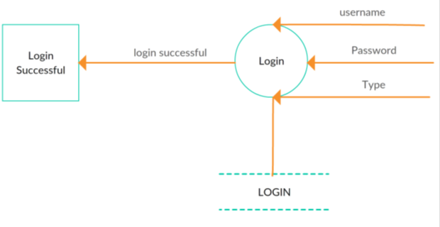
Fig 7: Dataflow diagram for login
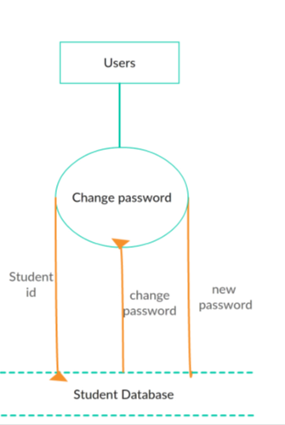
Fig 8:Dataflow diagram to change password

IDENTIFICATION AND DOCUMENTATION OF TEST SCENARIOS AND TEST CASES OF VIRTUAL LEARNING ENVIRONMENT

Test scenario 1:
Test Scenario | Test case | Pre-condition | Test-steps | Test-data | Expected result | Actual result | Pass/fail
Search for a course | 1.check response on the entering the valid course name | Must be connected to database. | 1.launch the application.  2. user must be logged in.  3.Enter the course name  4.Click on the search button | Course: C programming | Valid course name and display the course details. | Content regarding the course is displayed. | pass
Search for a course | 1.check response on the entering the valid course name | Must be connected to database. | 1.launch the application.  2. user must be logged in.  3.Enter the course name  4.Click on the search button | Course:  python | Content about the python programming. | Invalid course name | fail

Test scenario 2:
Test Scenario | Test case | Pre-condition | Test-steps | Test-data | Expected result | Actual result | Post Condition
Appear for test | 1.When user name is present in the list with valid hallticket. | User must login and register with course. | 1.launch the application.  2. user must be logged in.  3.Enter the course name  4.Click on the submit button | Hallticket no | Displays hallticket | Displays hallticket | “Pass”
Appear for test | 2. When user name is present in the list with invalid hallticket. | User must login and register with course | 1.launch the application.  2. user must be logged in.  3.Enter the course name  4.Click on the submit button | Hallticket no | Does not display hallticket. | Does not display hallticket. | “Fail”

View syllabus | 1. user can view the syllabus if he is registered to the course | User must login and register with course | 1.launch the application.  2. user must be logged in.  3.Enter the course name  4.click on view button | Course name: Python programming | Invalid course name | Does not display course syllabus | “Fail”
Test scenario 3:
Test Scenario | Test case | Pre-condition | Test-steps | Test-data | Expected result | Actual result | Post Condition
View syllabus | 1. user can view the syllabus if he is registered to the course | User must login and register with course. | 1.launch the application.  2. user must be logged in.  3.Enter the course name  4.click on view button | Course name: C programming | Valid course name and syllabus is displayed. | Valid course name and syllabus is displayed. | “Pass”
View syllabus | 1. user can view the syllabus if he is registered to the course | User must login and register with course | 1.launch the application.  2. user must be logged in.  3.Enter the course name  4.click on view button | Course name: Python programming | Invalid course name | Does not display course syllabus | “Fail”

EFFORT ESTIMATION FOR VIRTUAL LEARNING ENVIRONMENT

1.Functional point Estimation
2.COCOMO model Estimation
a. Basic COCOMO model
b. Intermediate COCOMO model
c. Detailed COCOMO model.

- Functional point estimation: To overcome the limitations for loc-based measurements Alan Albert proposed another size estimation technique called the function point(FP) analysis.
FP based estimation are based on following information domain values and their complexities in a particular project.
The values of each of these information domains is collected and a subjective evaluation is performed to categorize them as sample, arrange & complex.
weights
Information domain | Simple | Arrange | Complex
No.of inputs  No.of outputs  No.of inquires  No.ofinternal logical files  No.ofexternal interfaces | 3  4  3  7  5 | 4  5  4  10  7 | 6  7  6  15  10

The project VLE has the information domain values as follows:
No.of inputs-5
No.of outputs-5
No.of inquires-4
No.of internal logical files-10
No.of external interfaces-1
The project VLE is a simple project. We can find FP estimation as follows:
Unadjusted FP(UFP): It is calculated by counting the value of each information domain and multiplying by a approximate weight.
UFP = (No.of inputs) * weight + (No.of outputs ) * weight + (No. of interfaces) * weight + (No.of internal logical files) * weight + ( No.of external interfaces) * weight
UFP = (5*3) + (5*4) + (4*3) + (10*7) + (1*5)
= 122
Compute the complexity adjustment attributes (CAA):
The CAA’s are complexity attributes that are vary from project to project. They are computed using the following relationship.
CAA = [ 0.65 + 0.01 * ∑ CAAi ]
The complexity adjustment attributes for VLE are :
- Need for backup and recovery
- Online data entry
- Online update
- Performance critical
- Data communication required
- System runs in exisisting , heavily utilized operational environment
- Code designed to be reusable
- Application designed to facilitate change & speed of use by user
- Multiple screens
- Inputs , Outputs , File Complex
- Internal Processing Complex
The values of Each of these factors is rated on a five point scale.
O – not significant
1 – incidental
2 – moderate
3 – average
4 - significant
5 – highly essential
CAA = [ 0.65 + 0.01 * ∑ CAAi ]
= 0.65 + 0.01 * (11*2)
= 0.65 + 0.01 * 22
= 0.65 + 2.2
CAA = 0.87
To calculate FP the required formula is:
FP = UFP * CAA
= 122 * 0.87
= 106.14
The functional point Estimation for Virtual Learning Environment = 106.14Fp.

Detailed COCOMO Model:
The detailed COCOMO model inherits all the features of the intermediate COCOMO model for the overall description of the project cost for detailed planning and scheduling. It is necessary to access the impact of the cost drivers in a phased manner. The detailed COCOMO model uses different effort multipliers for each phase of the project.
The detailed COCOMO model defines the five life cycle phases for each effort distribution, plan and requirements system design, detailed design, ease and unit test and integration and test the percentage of effort in a phase varies with project size and the project nature.
The actual percentage of effort for virtual learning environment is calculated as follows.
Consider the requirement% estimation effort as (E) is 24.6889PM
=6+ (6-6)/(32-2)*5
=6%
Effort=0.06*24.6889
=1.481334PM
System design=17+ (17-17)/(128-32)*5
=17%
Effort=0.17*24.6889
=4.197113PM
Detailed design=24+ (25-24) / (28-32)*5
=24%
Effort=0.24*24.6889
=5.925336PM
Code and unit test=31+ (33-31) / (128-32)*5
=31%
Effort=0.31*24.6889PM
=7.653559PM
Integration and test=28+ (28-26)*(128-32)*5
=28%
Effort=0.28*24.6889
=6.912892PM

Basic COCMOModel:
The basic COCOMO model estimates effort in a function of the estimated KLOC in the proposed project. The basic model is very simple, quick and acquired and applicable to small to medium organic type projects. It is given as follows
Development effort (E) =a*(KLOC) ^ b
Development time (T) = c*(E) ^ b
Where a, b, c, d are constantsand determine form
Historical data:
KLOC=5
Developmenteffort (E) =3.0*(1.5) ^ 1.12
=18.19PM
Development time (T) =2.5*(18.19 ^ 0.35
=6.90 months
Total product development cost=development time*salaries of engineers
Staffing = effort/duration
=2.636

Intermediate COCMO model:
The basic COCOMO model determines the effect and time on the basics of project size. Therefore Boehm has introduced is 15 cost drivers, considering the various aspects of product development environment .These cost drivers are used to adjacent the project complexity for estimation factors(EAF)
Cost drivers and their values:
Cost drivers | Rating |  |  | values
Product attribute software reliability | Very high |  |  | 1.40
Database size | high |  |  | 1.08
Product complexity  Hardware attribute | High |  |  | 1.15
Required turn attribute | very high |  |  | 1.15
Memorystorage constraints | High |  |  | 1.06
Personal attributes | High |  |  | 0.86
Analyst capability | Nominal |  |  | 1.00
Application experience | Nominal |  |  | 1.00
Programming language  Experience project attributes | High |  |  | 0.91
Use of software tools |  | low | 1.10
Development schedule |  | nominal | 1.00

Development effort (E):
Initial effort(E) = a*(KLOC)^b
EAF = EAF1*EAF2*……*EAFn
Total development effort(E)= Ei*EAF
Development time (T) = c*(E)^d
The project virtual learning environment development cost is calculated as follows
EAF=1.14*1.08*1.15*1.15*1.06*0.86*1.00*1.00*0.91*1.10*1.00
=1.82PM
Total development effort=Ei *EAF
=18.19*1.82
=33.10
Therefore by using intermediate COCOMO model the development effort for virtual learning environment is 33.10PM

